# LostPaws

Desktop and Mobile Website User Interface

**Members**

Aguas, Carl Patrick Adrian Carbonell, Angela Gabrielle Guerrero, Vladimir

Juico, Joseph Harvey Poblete, Jared

Tolledo, Raphael Alexei

FOPI01

# Desktop Interface

Splash Screen



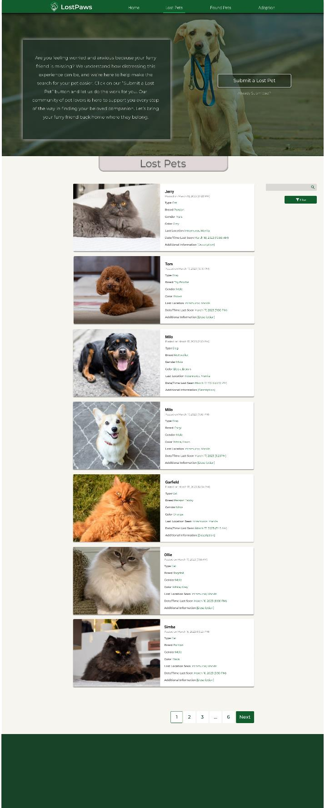

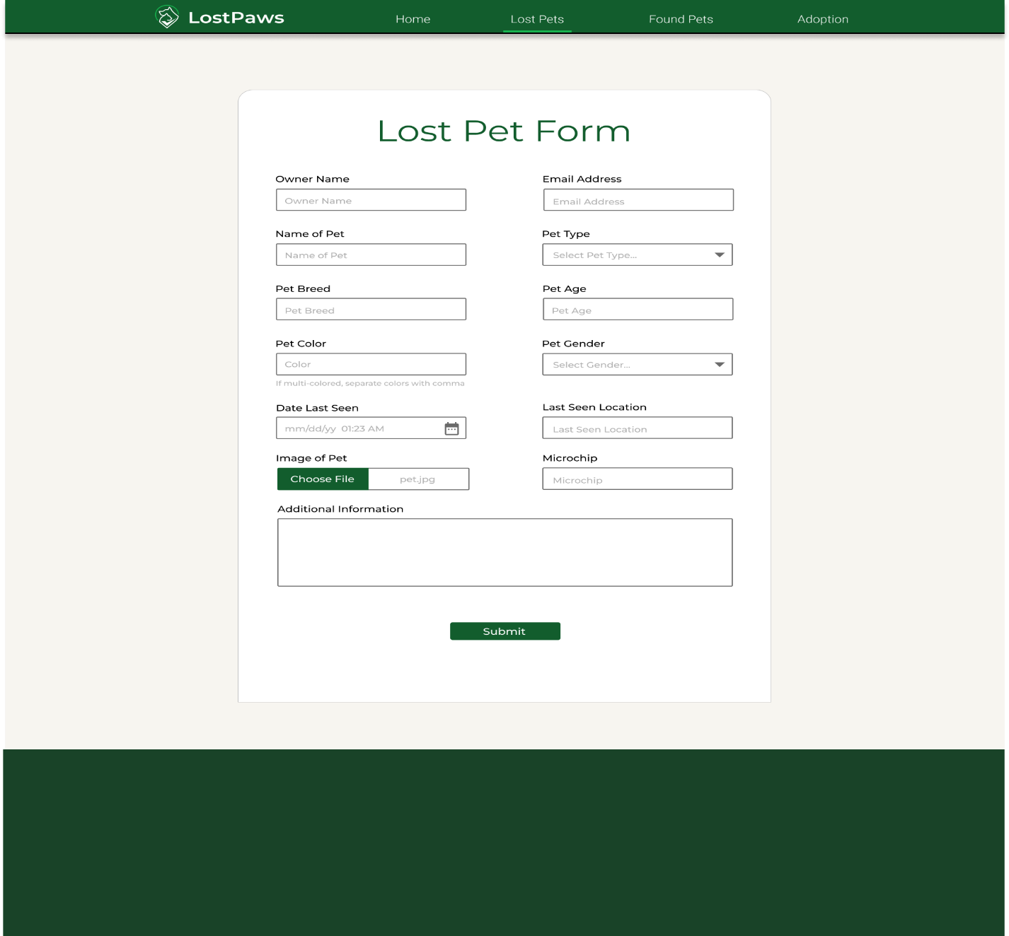

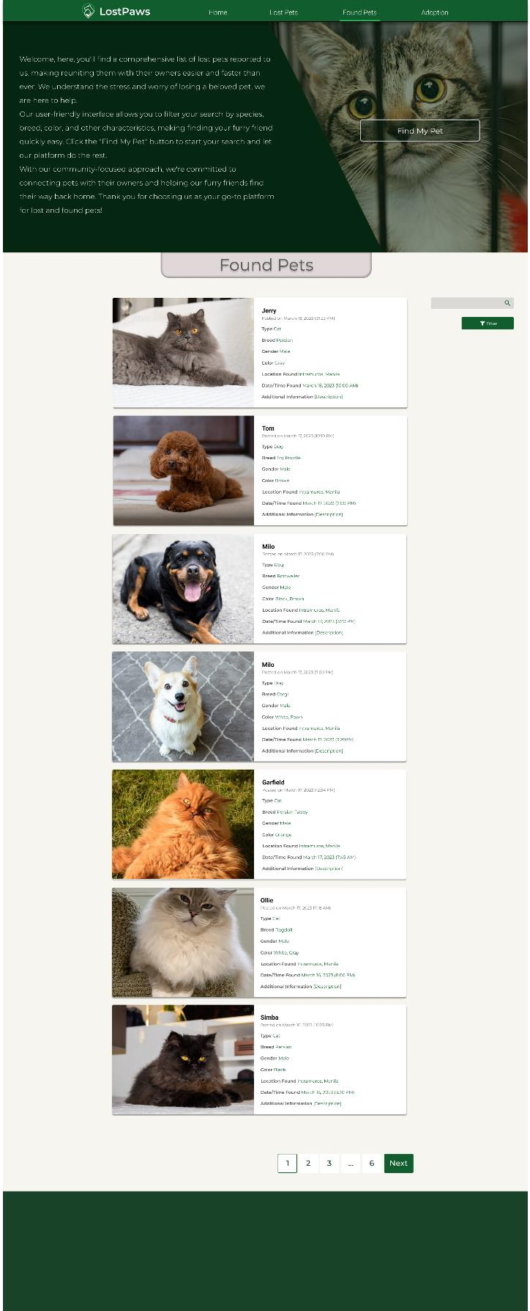

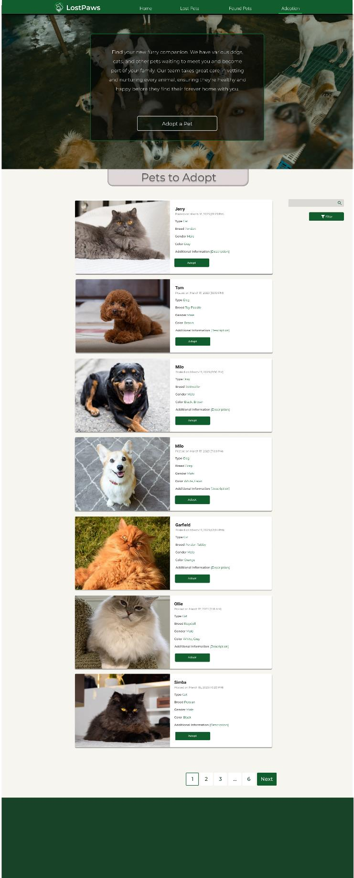

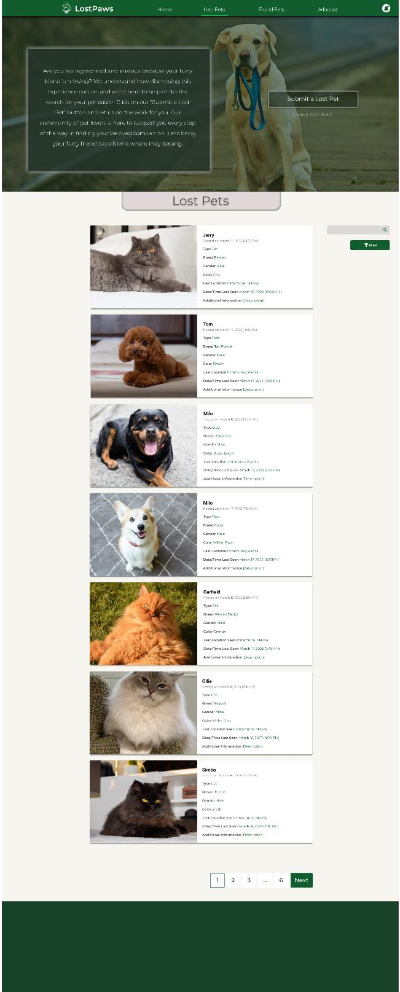 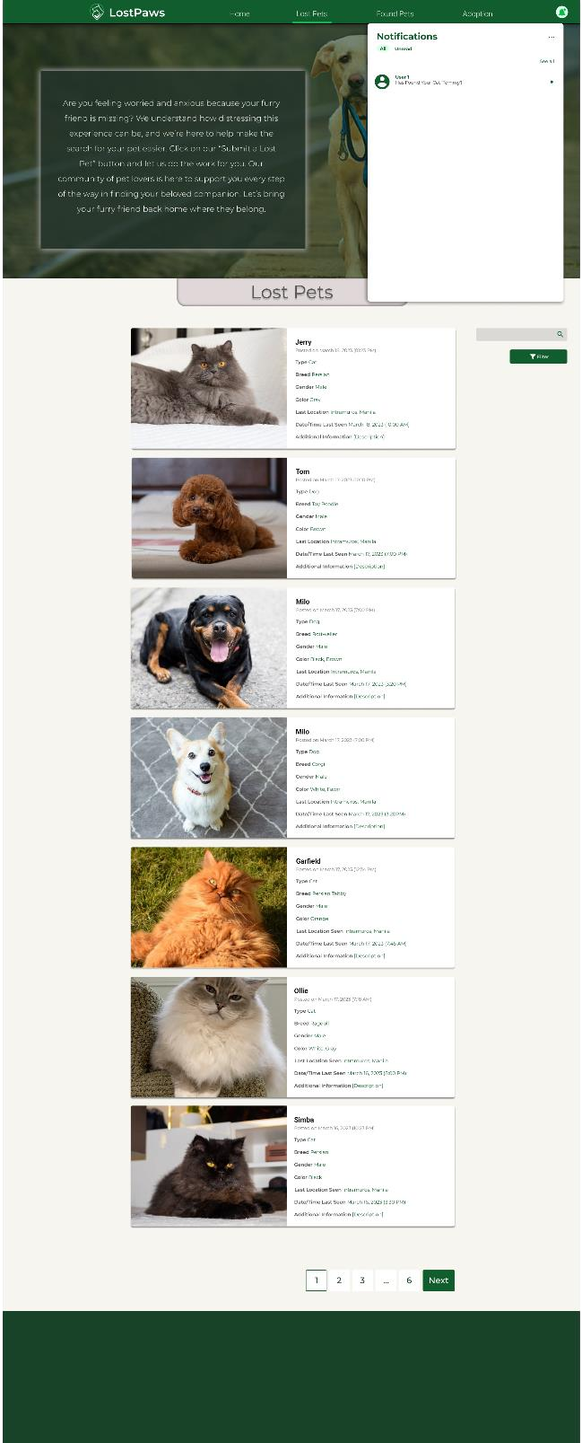

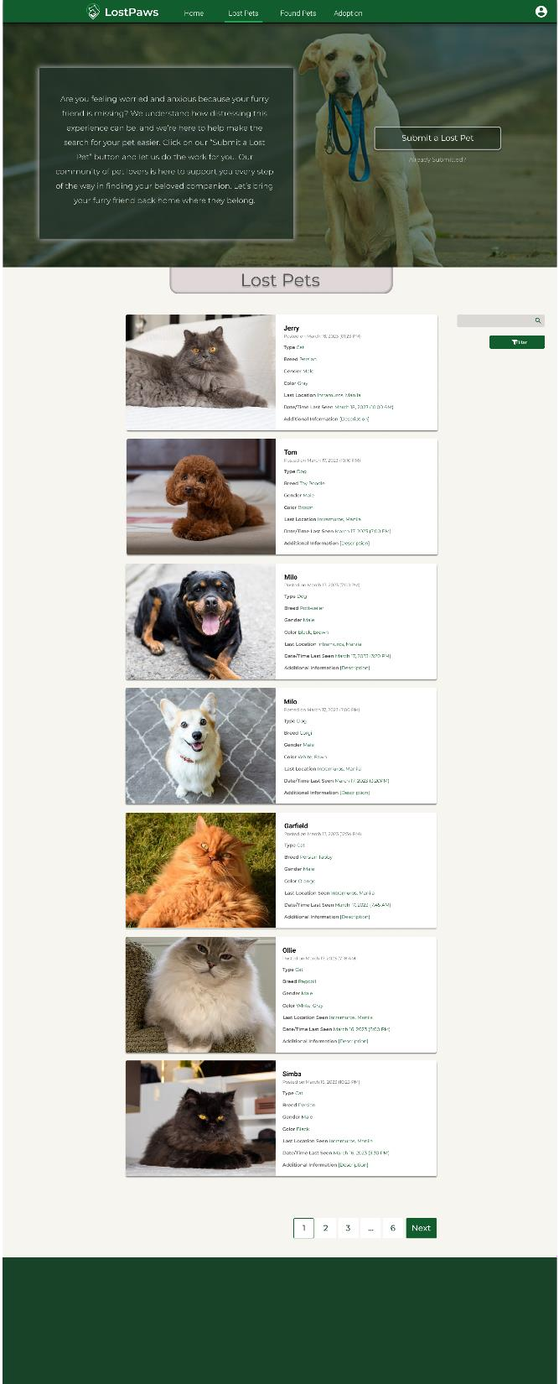 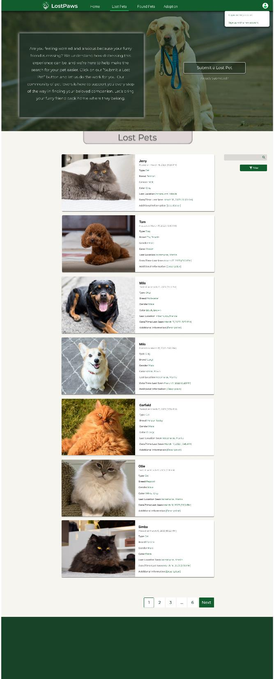

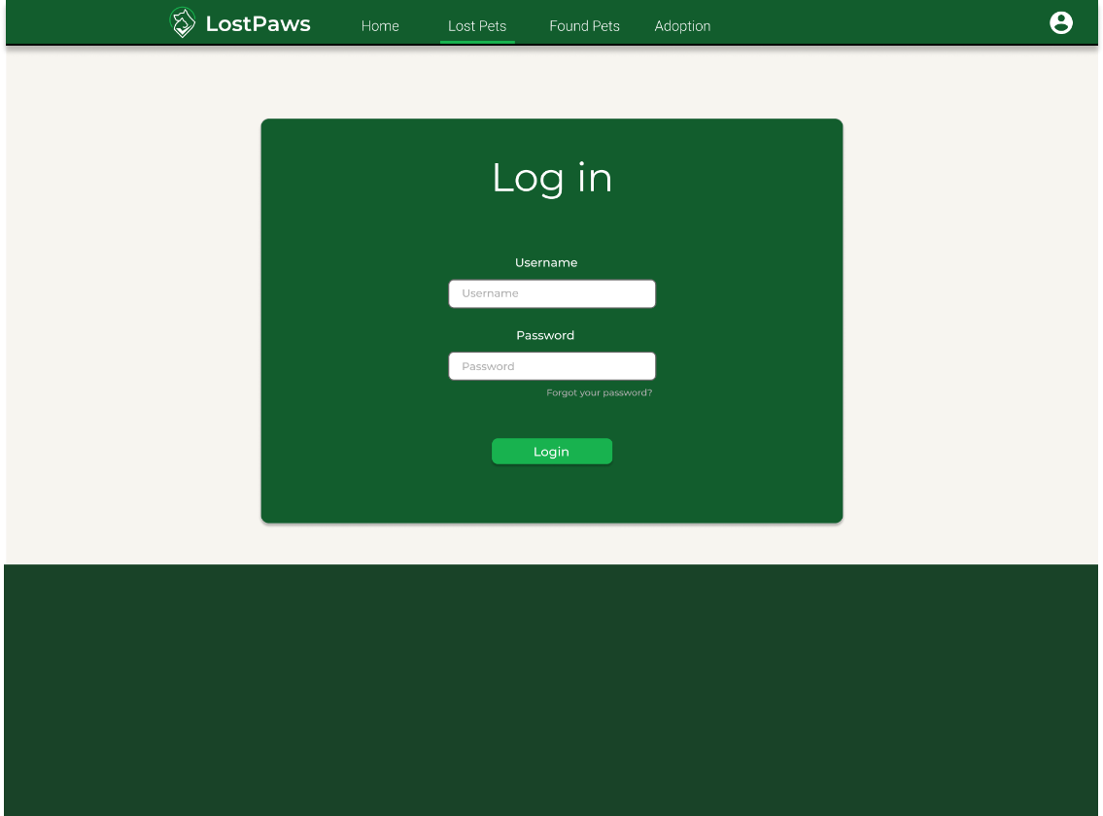

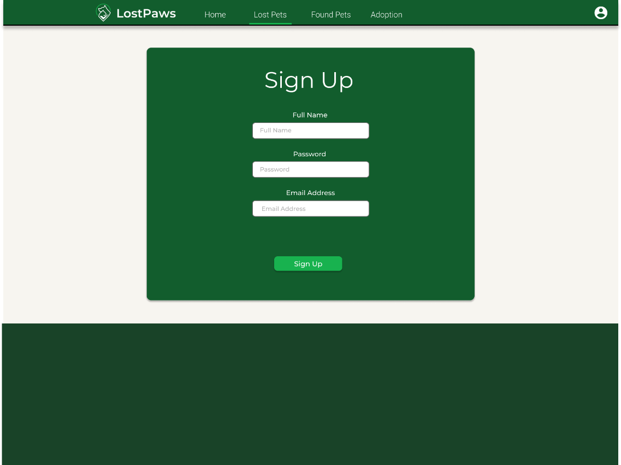

# Mobile Interface

Splash Screen

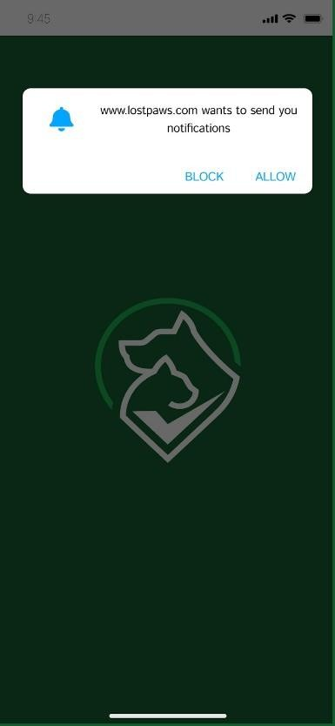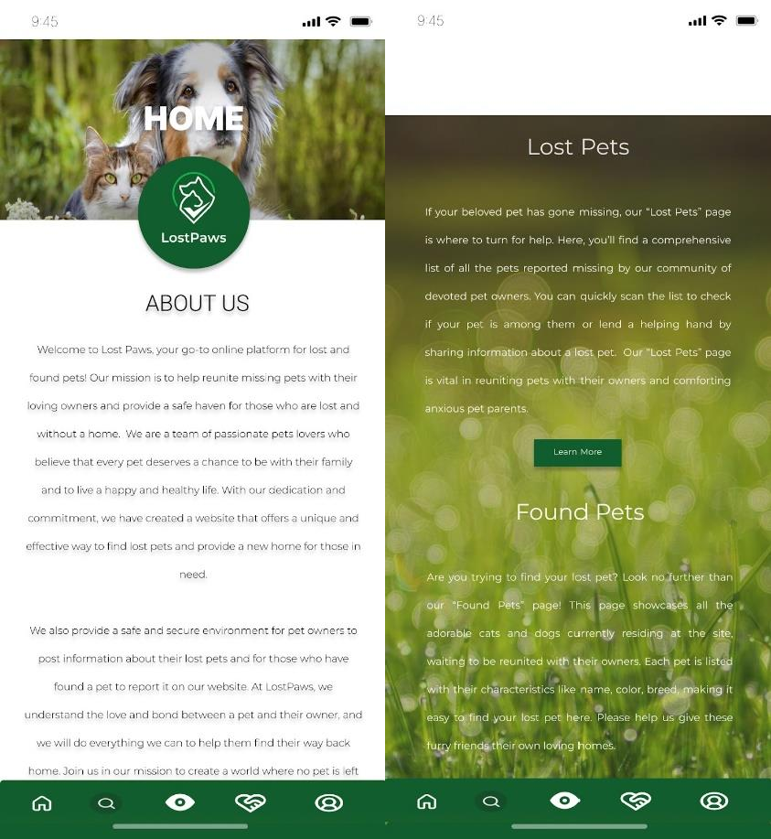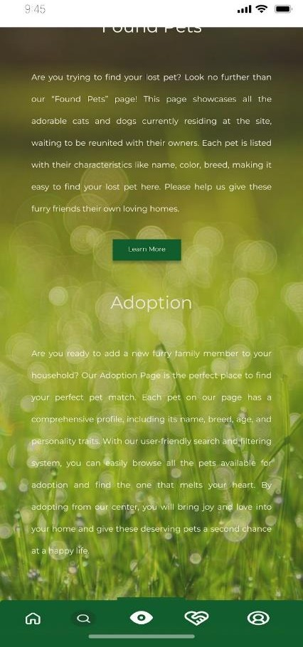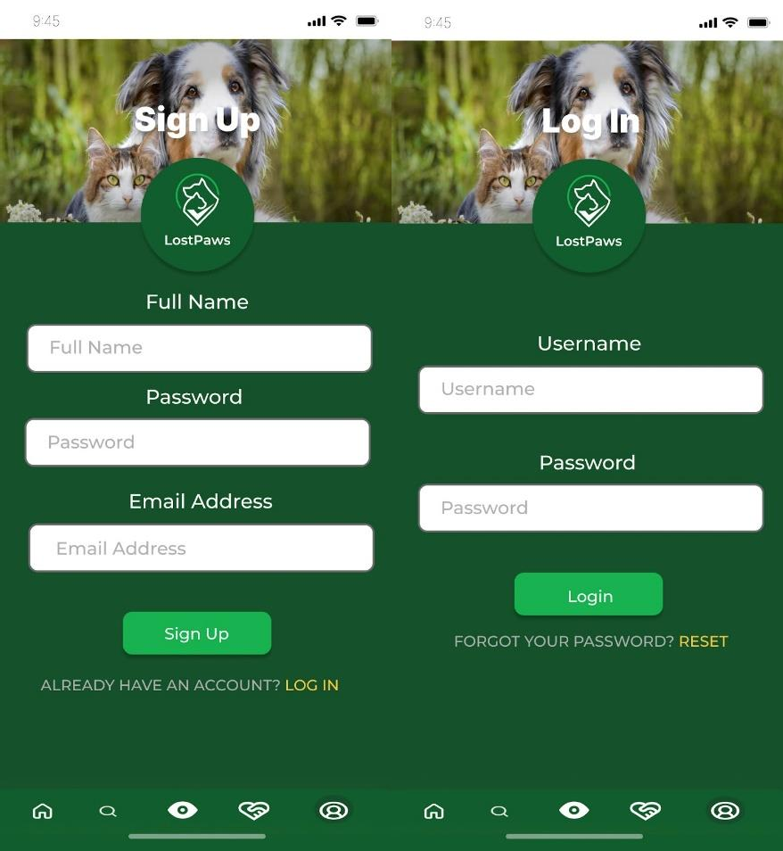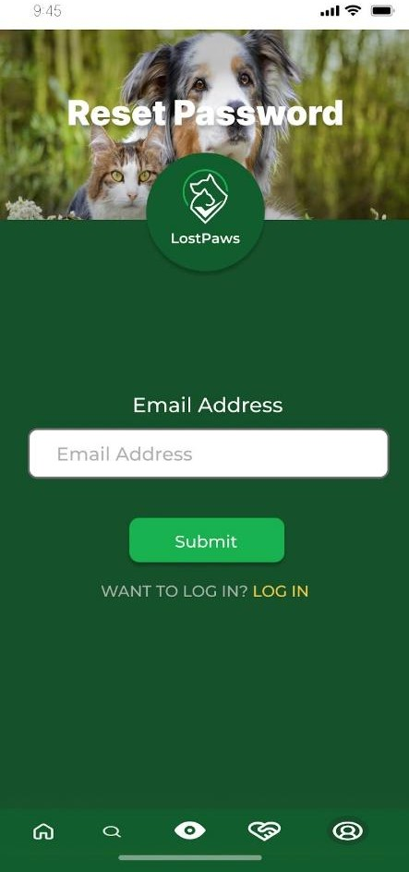

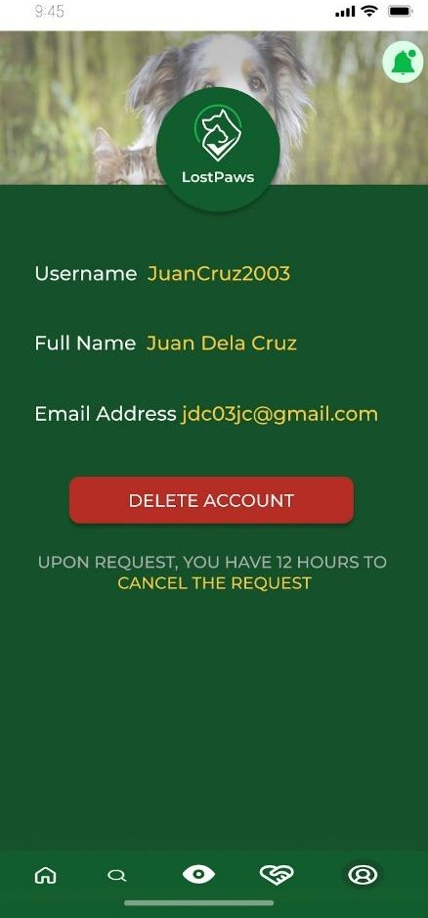

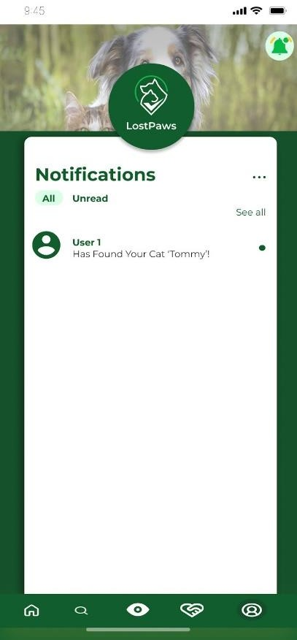

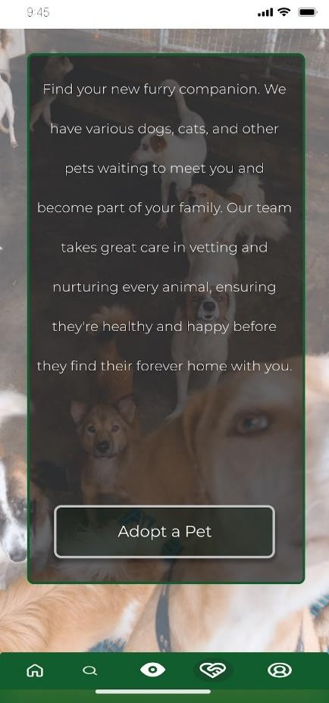

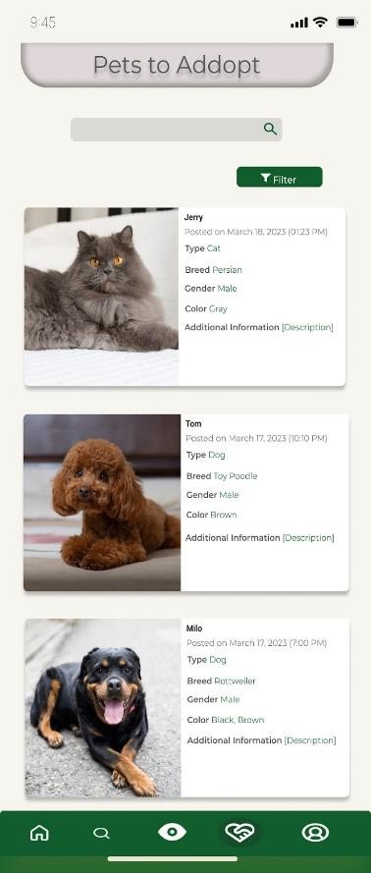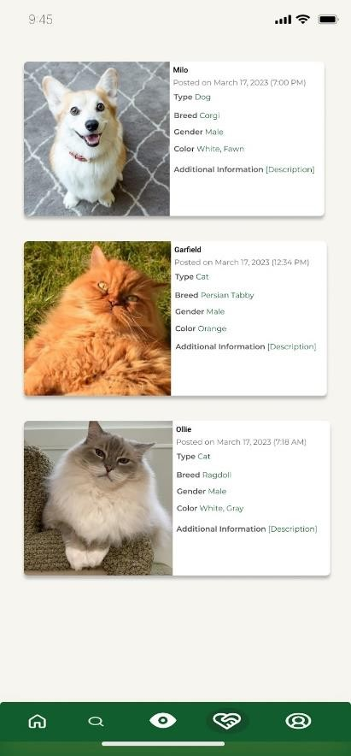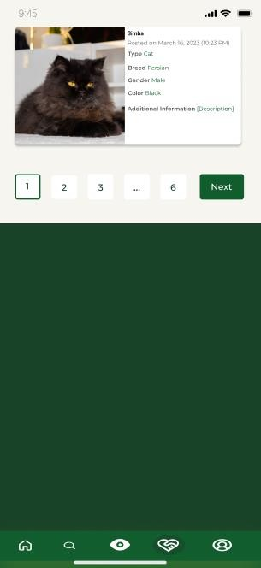

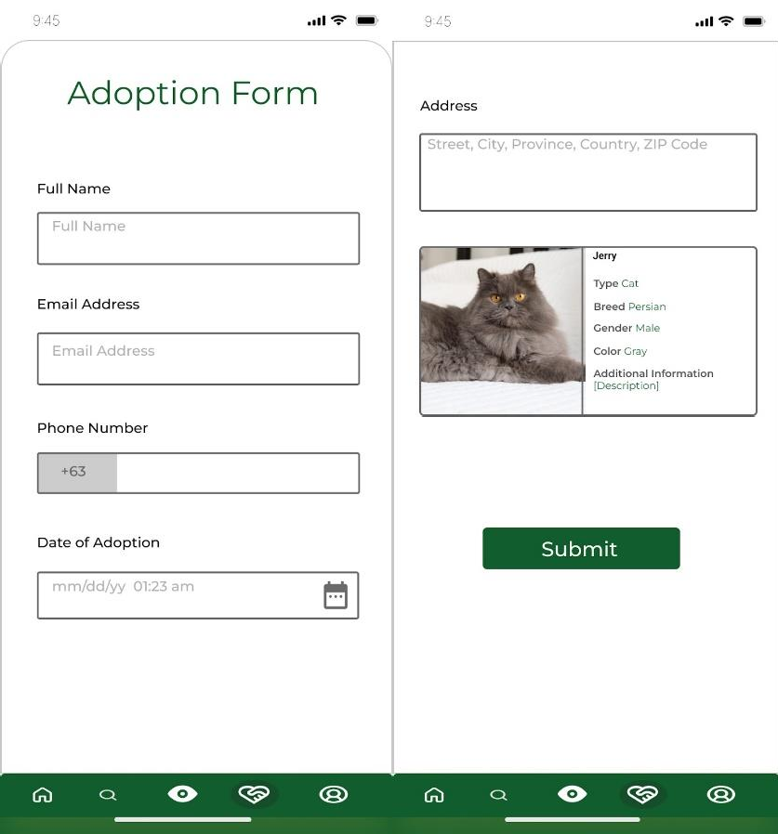

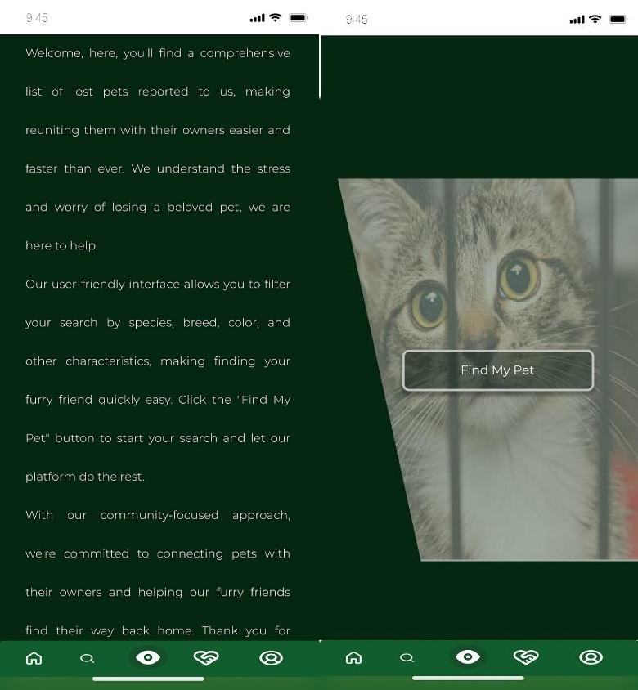

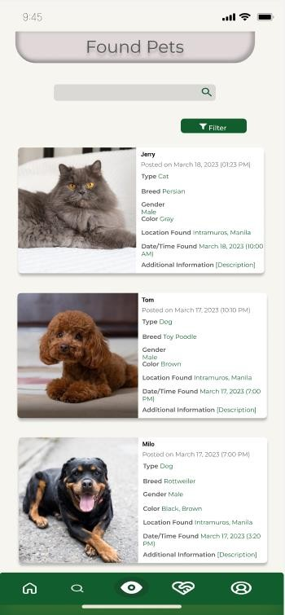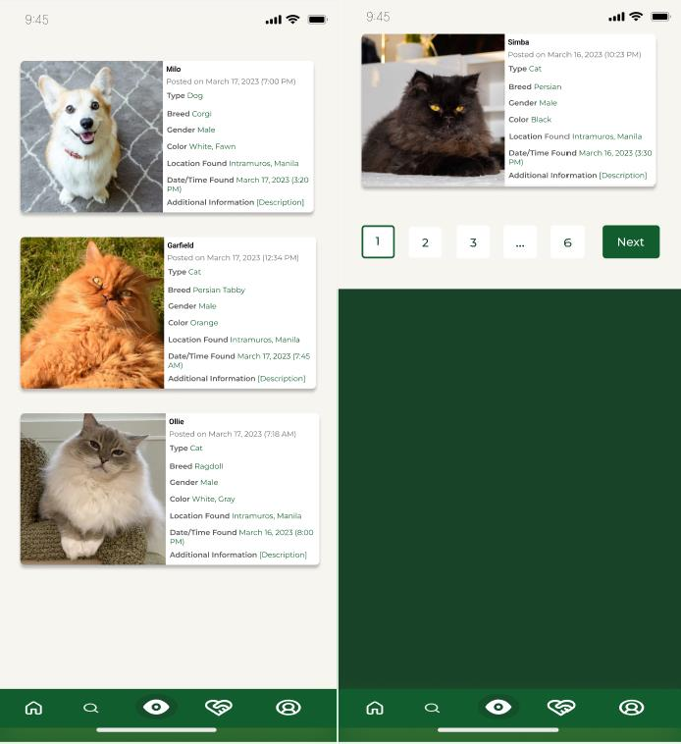

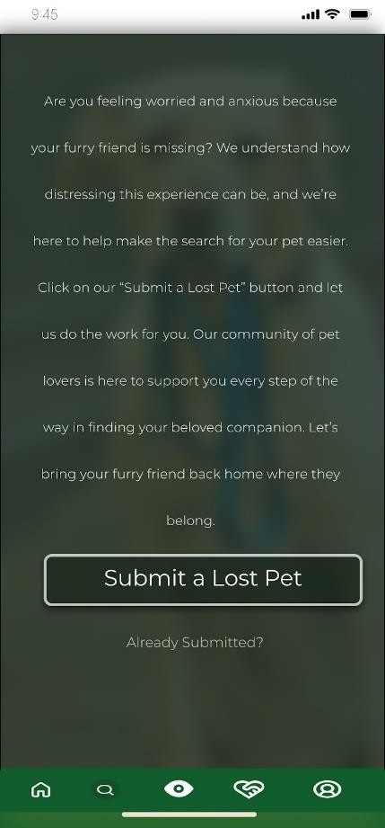

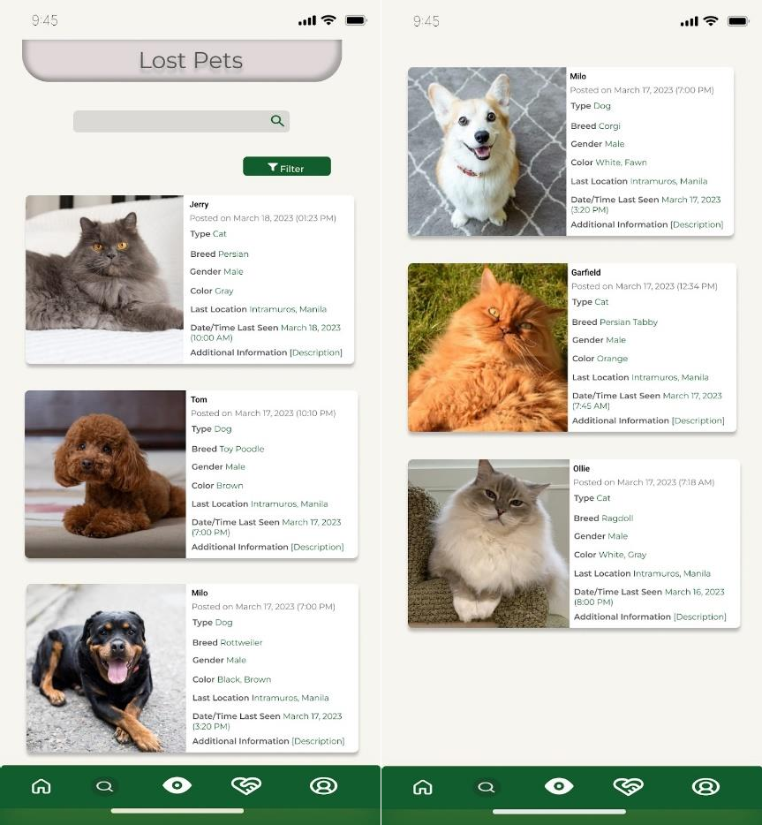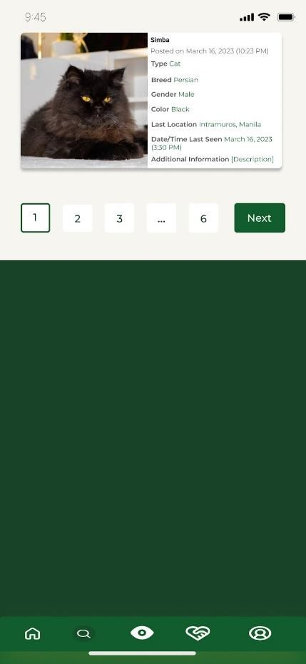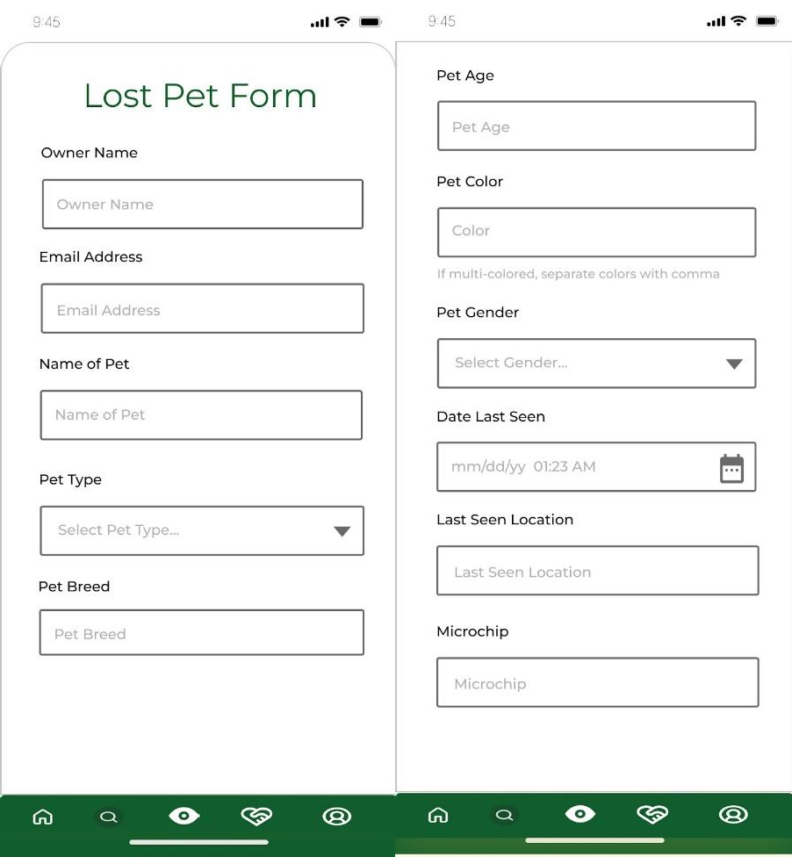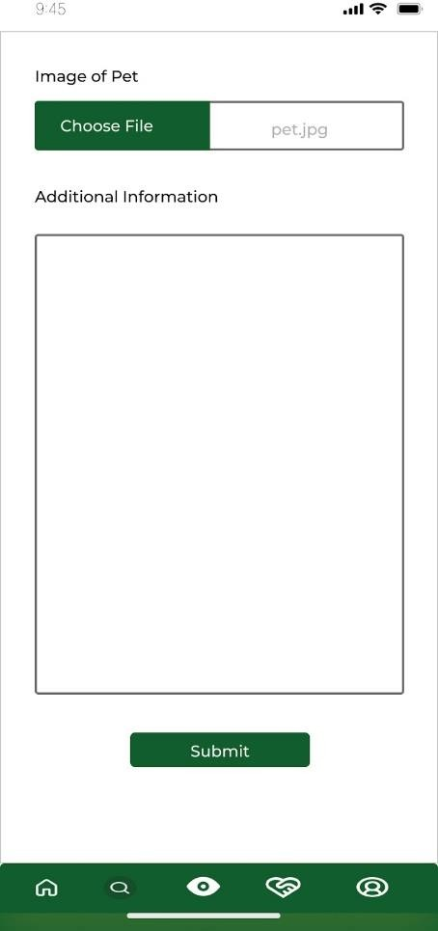

Created with Figma:

* [https://www.figma.com/file/ztehQALlVxfxp2Ll38Y0mL/Lost-Paws?node-](https://www.figma.com/file/ztehQALlVxfxp2Ll38Y0mL/Lost-Paws?node-id=378%3A949&t=gmYSm1QDPcOQmcl2-1) [id=378%3A949&t=gmYSm1QDPcOQmcl2-1](https://www.figma.com/file/ztehQALlVxfxp2Ll38Y0mL/Lost-Paws?node-id=378%3A949&t=gmYSm1QDPcOQmcl2-1)
* [https://www.figma.com/file/5W64tkdphymssxQjSXJ8pL/Lost-Paw-Mobile?node-](https://www.figma.com/file/5W64tkdphymssxQjSXJ8pL/Lost-Paw-Mobile?node-id=0%3A1&t=WLkmqasmdJ38224o-1) [id=0%3A1&t=WLkmqasmdJ38224o-1](https://www.figma.com/file/5W64tkdphymssxQjSXJ8pL/Lost-Paw-Mobile?node-id=0%3A1&t=WLkmqasmdJ38224o-1)